**Nominal Exchange Rate:** It is denoted by $S$, and defined as the amount of domestic currency that can fetch one unit of foreign currency. It is the rate at which currencies are exchanged in the foreign exchange market. It is also the price of foreign currency in terms of the domestic currency. We will consider the foreign country is the US and the domestic country is India. The unit of the nominal exchange rate in our analysis is $\frac{Rs}{\$}$. When nominal exchange rate rises, it means you have to spend more domestic currency to obtain one unit of foreign currency. It implies a reduction in value of domestic currency. It is known as depreciation of domestic currency. It also implies a depreciation of nominal exchange rate. Hence, a rise in nominal exchange rate is known as the depreciation of exchange rate.

**Real Exchange Rate:** It is the rate at which goods are exchanged between two countries. It is denoted by $p$ in our analysis. By definition, $p=\frac{SP^{*}}{P}$, where, $P^{*}$ is the price of foreign good produced in foreign country and priced in foreign currency (USD), and $P$ is the price of the same good produced in the domestic country and denominated in domestic currency (INR). It is a unit free measure. It represents the relative price of good produced in the foreign country and the good produced in the domestic country after converting in same domestic currency unit.

Define, net export (NX)=X-M, $NX\left(p\right), \frac{∂NX}{∂p}>0$. Hence, $\frac{∂NX}{∂S}>0$ given $P^{*}$ and $P$

$$Y=C\left(Y-T\right)+I\left(r\right)+G+NX(p)$$

**Purchasing Power Parity (PPP):** Satisfaction of PPP implies same good is priced identically across the worlds. PPP implies, p=1 . PPP does not hold for non-tradable goods. PPP also does not hold in the presence of trade barriers, e.g., tariff, quota, etc.

**Interest Rate Parity:** This implies capital/investment should have identical return internationally

$i^{*}$ is the return of 1 USD deposit to a US bank after one year. The total return after one year is USD $\left(1+i^{*}\right)$.

A deposit of USD 1 to the Indian bank yields return INR $S\left(1+i\right)$ after one year. Suppose, nominal exchange changes from $S$ to $S^{'}$. Hence, the return in terms of USD is, USD $\frac{S\left(1+i\right)}{S^{'}}$

If interest rate parity is satisfied then,

$$\left(1+i^{*}\right)=\frac{S\left(1+i\right)}{S^{'}}$$

**Covered Interest Rate Parity:** When $S^{'}=F$, where *F* is a forward exchange rate on which the individual is at a forward contract. The contract is about a future payment in terms of USD determined a year ago at the time of deposit. It safeguards the individual from the uncertainty of future exchange rate fluctuations.

$$\left(1+i^{*}\right)=\frac{S\left(1+i\right)}{F}$$

$$\frac{\left(1+i^{*}\right)}{\left(1+i\right)}=\frac{S}{F}$$

Covered Interest Rate Differential:



$$\left(1+i\right)-\left(1+i^{*}\right)\frac{F}{S}$$

**Determination of Nominal Exchange Rate:**

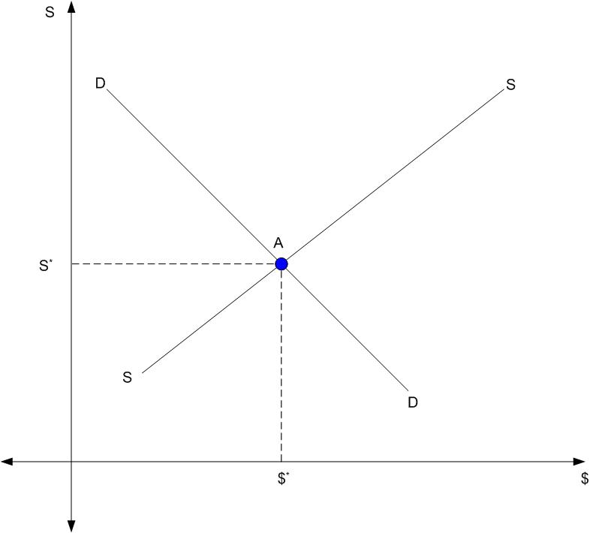

$$\$^{d}=d_{0}-d_{1}S$$

$$\$^{s}=σ_{0}+σ_{1}S$$

$$S^{*}=\frac{d_{0}-σ_{0}}{d_{1}+σ_{1}}$$

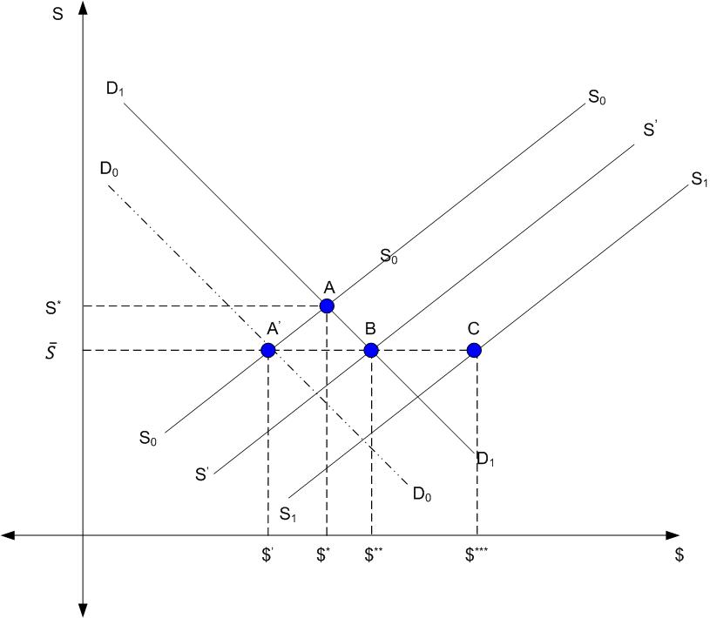

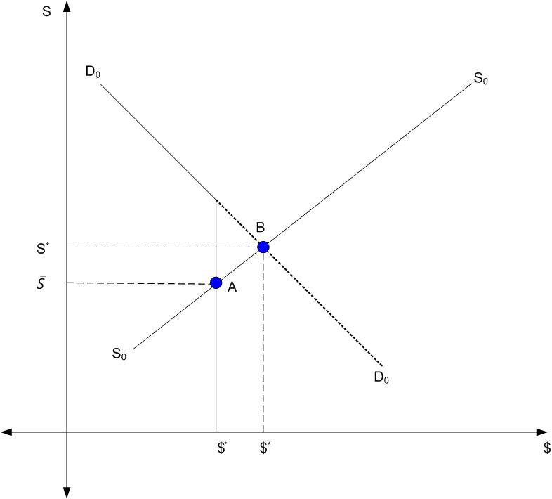

$$\$^{d}=d_{0}-d_{1}S, \$^{d}<\$^{'}$$

$\$^{d}=\$^{'}$**otherwise**

$$\$^{s}=σ_{0}+σ_{1}S$$

$$\$^{'}=σ_{0}+σ_{1}S$$

$$\overline{S}=\frac{\$^{'}-σ_{0}}{σ_{1}}$$

$$\$^{d}=d_{0}-d_{1}\overline{S}$$

Excess demand for dollar

$$\$^{d}-\$^{'}$$

$$d_{0}=100, d_{1}=10$$

$$\$^{'}=60$$

$$σ_{0}=50, σ_{1}=10$$

$$S^{*}=\frac{d_{0}-σ_{0}}{d_{1}+σ_{1}}=2.5$$

$$\$^{*}=100-10*2.5=75$$

$$60=50+10S$$

$$\overline{S}=1$$

$$\$^{d}=100-10*1=90$$

Excess Demand, 90-60=30

**Balance of Payment (BOP) Identity:** It follows the rule of double entry accounting system

**Current Account (CA) + Financial Account (FA) = 0**

CA = Trade Balance (TB) + Interest Income from Net Foreign Assets

TB = Export (X) – Import (M)

FA = Domestic Assets owned by Foreign Country – Foreign Assets owned by Domestic Country

Current Account (CA) = - Financial Account (FA) = Foreign Assets owned by Domestic Country - Domestic Assets owned by Foreign Country = $∆NFA=NIIP$





$$Y-T+Interest Income from Net Foreign Assets=C+I+G-T+X-M+Interest Income from Net Foreign Assets$$

$$GNP=C+I+G-T+CA=C+I+G-T+∆NFA$$

$$GNP-C-I=G-T+∆NFA$$

$$S-I=G-T+∆NFA$$

Current Account (CA) = $∆NFA$ = $∆{NFA}_{PR}+∆{NFA}_{CB}$

$$CA-∆{NFA}_{PR}=∆{NFA}_{CB}$$

$$CA+KI=∆{NFA}_{CB}$$

$$KI=-∆{NFA}_{PR}$$

$$KI (r-r^{*})=-∆{NFA}_{PR}=-\left(Foreign Interest bearing Assets Owned by Domestic Country-Domestic Interest bearing Assets Owned by Foreign Country\right)=Domestic Interest bearing Assets Owned by Foreign Country-Foreign Interest bearing Assets Owned by Domestic Country$$

$$CA(p,y,r^{*})+KI(r-r^{*})=∆{NFA}_{CB}$$

$$\frac{∂(CA)}{∂p}>0; \frac{∂(CA)}{∂y}<0; \frac{∂(KI)}{∂(r-r^{*})}>0$$

$$CA\left(p,y,r^{*}\right)+KI\left(r-r^{*}\right)>0⇒BOP Surplus$$

$$CA\left(p,y,r^{*}\right)+KI\left(r-r^{*}\right)<0⇒BOP Deficit$$

**IS:**

$$y=C\left(y-T\right)+I\left(r\right)+G+NX(p,y)$$

$$\frac{∂(NX)}{∂p}>0, \frac{∂(NX)}{∂y}<0$$

**LM:**

$$\frac{M}{P}=L\left(y,r\right)$$

**BP:**

$$CA(p,y,r^{*})+KI\left(r-r^{*}\right)=∆{NFA}_{CB}$$

$$NX\left(p,y\right)+r^{*}b+KI\left(r-r^{*}\right)=∆{NFA}_{CB}$$

$$\frac{∂CA}{∂p}>0, \frac{∂CA}{∂y}<0, \frac{∂KI}{∂\left(r-r^{*}\right)}>0$$

**BP=0 curve:**

$$\frac{∂NX}{∂y}dy+ \frac{∂KI}{∂\left(r-r^{*}\right)}dr=0$$

$$\frac{∂r}{∂y}=-\frac{\frac{∂NX}{∂y}}{ \frac{∂KI}{∂\left(r-r^{*}\right)}}>0$$

Closed Capital Market: $\frac{∂KI}{∂\left(r-r^{*}\right)}=0 ⇒\frac{∂r}{∂y}→∞$

Completely Open Capital Market: $\frac{∂KI}{∂\left(r-r^{*}\right)}→∞ ⇒\frac{∂r}{∂y}=0$. This is also known as foreign and domestic assets are perfect substitutes. In this case market force will always ensure $r=r^{*}$

**Interest Rate Parity:**

$$r-r^{*}=f-s$$

$$C=β\left(y-T\right), I=-γr, M=η_{2}y;X=η_{1}p;NX=η_{1}p-η_{2}y$$

${\left(\frac{∂r}{∂y}\right)}_{O}=-\frac{1-β+η_{2}}{γ}$;

$${\left(\frac{∂r}{∂y}\right)}_{C}=-\frac{1-β}{γ}$$

$$\frac{{\left(\frac{∂r}{∂y}\right)}_{O}}{{\left(\frac{∂r}{∂y}\right)}_{C}}-1=\frac{1-β+η_{2}}{1-β}-1=\frac{η_{2}}{1-β}>0$$

$$CA+KI=Δ{NFA}_{CB}$$

$$KI=θ\left(r-r^{*}\right)$$

$$CA=η_{1}p-η_{2}y$$

$${\left(\frac{∂r}{∂y}\right)}_{BP=0}=\frac{η_{2}}{θ}$$

Let, $θ→0$, ${\left(\frac{∂r}{∂y}\right)}_{BP=0}→∞$

Let, $θ→∞$, ${\left(\frac{∂r}{∂y}\right)}_{BP=0}→0$